YOU’RE INVITED
RECEIVE A PERSONAL DIETARY ANALYSIS WORTH
£200

From turkey twizzlers to superfoods, hunger and food banks to fast food and obesity.
One way or another, nutrition affects us all on a daily basis.
Type 2 diabetes, heart disease and cancer are on the increase in the UK and many of these cases are linked to diet.
More research is needed to help improve diet and the health of the nation.
Interested?
Download
NOW
for
instructions
see page 8
St. Mary’s University and Inspiration f.m. have formed an
alliance to produce the first ever study into the nutritional
status of Inspiration f.m listeners.
With diversity and equality at the forefront,
we are inviting you to participate in a multicultural,
community study.

INFORMATION SHEET

Different Strokes for Different Folks
Private reflection of body image as a precursor to dietary behaviour
This research is funded by St. Mary’s University, Sports, Health and Applied Science dept. Twickenham.

PART A.
Some ethnicities have a higher risk of developing high blood pressure, heart disease, stroke and type 2 diabetes which are also linked to diet.
The study aims to gain insight into diet of Insp F.M listeners as a representative sample of ethnically diverse towns across the UK.
You will need to provide your name or contact details on the consent form. To ensure confidentiality, all information is submitted anonymously, securely stored on university software and individuals are identified by a number.
Contact us
Sheena Rose, email; 143000@live.stmarys.ac.uk Phone; 07557673369
Anne Majumdar, email; anne.majumdar@stmarys.ac.uk Phone; 0208 240 4073
PART B.
You have been invited to participate in research into the diet of Northampton residents, with special consideration made to include people of ALL ethnicities.
The study is in two parts and should not require more than a total of 60 minutes. Just remember to record ALL food and drinks you have consumed on three separate week days.
PART 1 involves some questions about you such as your age group, ethnicity, male or female and a three day food diary including five additional questions relating to your diet.
PART 2 Includes a maximum of 20 questions and answers which requires you to select which answer most represents yourself and a second three day food diary including five additional questions relating to your diet.
Participation is strictly voluntary, if you change your mind at anytime throughout the study your choice will be respected. Simply let us know via contacts and we will withdraw you from the study immediately, your data will not be used for any other purposes.
Information and data will be stored electronically on St Mary’s University servers.
Every care has been taken to ensure that there are no adverse reactions from this study. However, if you feel unwell for any reason whether it is related to this trial or otherwise, you should not continue.
Successful participants will benefit from a FREE dietary analysis using Nutritics professional nutritional analysis.
Remember, you don’t even have to provide your name so the information is COMPLETELY ANONYMOUS.
Additional Information

To safeguard anonymity, a four-digit code suggested as last four digits of telephone number is all that is required to identify subjects. This procedure is mandatory, primarily for autonomy purposes such as a request to withdraw from the study but also to compare individuals pre/post nutrient intake.

A valid email or correspondence address must be provided to receive complimentary dietary analysis. Correspondence details will be secured separately from the study data and confined in accordance with the general data protection act 2018 https://www.gov.uk/government/collections/data-protection-act-2018

No persons other than Sheena Rose (researcher) and Anne Majumdar (supervisor) have full access the data. All data is stored electronically on St Mary’s University secure servers.

In the event of publication, data will be kept for a period of 10 years. The data cannot identify people or places only ethnicity, age group, gender and dietary intake.
CONSENT FORM

Name of Participant: _________________________________________

Title of the project: Different Strokes for different Folks; Private reflection of body image as a precursor to dietary behaviour;

Main investigator and contact details:
Sheena Rose, email; 143000@live.stmarys.ac.uk Phone; 07557673369
Anne Majumdar, email; anne.majumdar@stmarys.ac.uk Phone; 0208 240 4073

Members of the research team: Sheena Rose and Anne Majumdar.

1. I agree to take part in the above research. I have read the participant information sheet which attached to this form. I understand what my role will be in this research, and all of my questions have been answered to my satisfaction.

2. I understand that I am free to withdraw from the research at any time, for any reason and without prejudice.

3. I have been informed that the confidentiality of the information I provide will be safeguarded.

4. I am free to ask any questions at any time before and during the study.

5. I have been provided with a copy of this form and the Participant Information Sheet.

6. I have read and understand the inclusion and exclusion criteria outlined in the enclosed information sheet.

Data Protection: I agree to the University processing personal data which I have supplied. I agree to the processing of such data for any purposes connected with the Research Project as outlined to me.

Name of participant print name………………………………………………………………………

Signed………………..……………. Date………………………….........

WITHDRAWAL FORM

REMEMBER! ! ! YOU ARE FREE TO WITHDRAW FROM THIS STUDY AT ANYTIME.
---------------------------------------------------------------------------------------------------------
If you wish to withdraw from the research, please complete the form below and return to the main investigator named above.

Title of Project: Different Strokes for different Folks; Private reflection of body image as a precursor to dietary behaviour.

I WISH TO WITHDRAW FROM THIS STUDY

I.D number (last four digits of telephone number)________________________________

Signed: __________________________________ Date: _____________________

ONLY FILL THIS FORM IN IF YOU WISH TO WITHDRAW FROM THE STUDY

APPLICATION FORM

To ensure equality and diversity throughout this study please submit your information below.
To safeguard your anonymity, you are not required to give your name, instead, please provide the last four digits of your phone number as your identification number.
I.D Number. | Last 4 digits of phone number e.g 3369
Male/Female/Other
Prefer not to say
Ethnicity
Country of birth
Age Group
18-30,
Age Group
31-45,
Age Group
46-60,
Age Group
60+
Weight | Kg | Stone /Llb
Height | cm | Feet/inches
To receive your FREE NUTRITIONAL ANALYSIS enter an email or postal address.
Please note that free dietary analysis is for participants INCLUDED in this study.

I understand the terms and conditions of this study and hereby give my informed consent to participate on a voluntary basis. | X . . . . . . . . . . . . . . . . . . . . . . . . . . . . .

COMPLETE THREE FULL DAYS OF FOOD & DRINKS CONSUMED BETWEEN MONDAY AND FRIDAY
 | MONDAY | TUESDAY | WEDNESDAY | THURSDAY | FRIDAY
BREAKFAST
SNACKS
LUNCH
SNACKS
DINNER
SNACKS
EXTRAS

COMPLETE THREE FULL DAYS OF FOOD & DRINKS CONSUMED EXAMPLE** BETWEEN MONDAY AND FRIDAY **EXAMPLE
 | MONDAY | TUESDAY | WEDNESDAY | THURSDAY | FRIDAY
BREAKFAST | Tea 2 sugars  3 scrambled eggs, 2 toast  Kingsmill white thick sliced | SAMPLE  FOOD  DIARY | 75g All bran, banana, soya milk.  2 coffees black no sugar | Innocent smoothie  Peppermint tea
Homemade?
Ready meal?
Restaurant/café?
Take out/delivery?
SNACKS | Costa coffee  Medium latte, blueberry muffin |  | Water, fresh apple. | Lemon and ginger tea,  Graze Mixed nuts 100g | SAMPLE  FOOD  DIARY
LUNCH | Subway turkey salad sub regular size, diet coke,  Take out/delivery | SAMPLE  FOOD  DIARY | Walkers ready salted crisps, grab bag size | Home made Tuna salad, lettuce 6 cherry tomatoes, handful olives, 1teaspoon mayonnaise
SNACKS | Banana, 500ml Water, |  | Coke zero | KitKat chunky, white tea with sweetener
DINNER | Tesco sweet and sour chicken and rice 450g,  Ready meal.  Handful of red seedless grapes  Oyster bay sauvignon blanc, 2 large glasses |  | Eat all you can Indian buffet,  Restaurant.  2 onion bhajis, small bowl of chicken tikka masala, small lamb jalfrezi pilau rice, ½ naan bread. 2 cobra beers, | Homemade spaghetti bolognaise, with Dolmio sauce and grated parmesan.  Fresh peppers & mushrooms.  Asda Garlic baguette, 3 slices  Robinson orange squash no added sugar. | SAMPLE  FOOD  DIARY
Home made?

Ready meal?

Restaurant/café?

Take out/delivery?

SUPPER & Extras | Cup of cocoa, 3 digestive biscuits.  Protein bar at gym 1l water |  | Three cups of tea through the day, white no sugar.  Pack of skittles

HOW TO DOWNLOAD AND SUBMIT YOUR FORMS

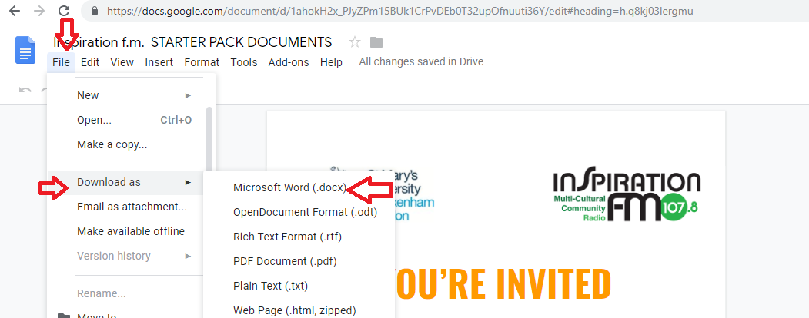

- In the task bar above the page, select File.
- Download as ➤
- Microsoft Word (.docx).

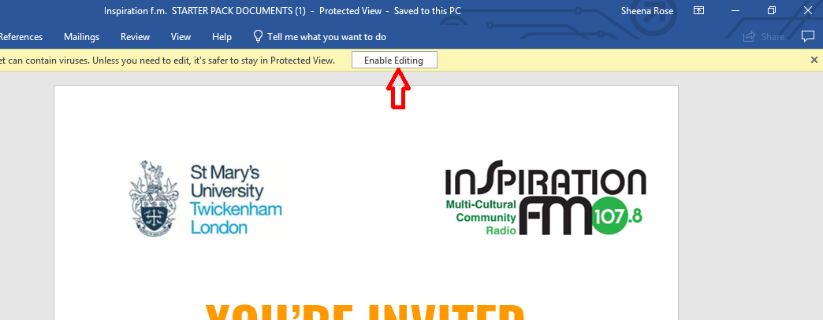

- Once downloaded, click Enable Editing and complete ALL forms.

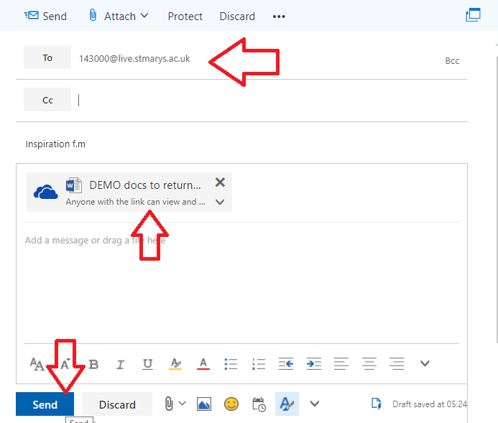

Return your documents to

143000@live.stmarys.ac.uk

